**1. Executive Summary**

Netlink proposes to implement a comprehensive RPA (Robotic Process Automation) Technical Architecture Program for Dubai Holding. The goal of this program is to define a robust automation platform architecture, select and implement an appropriate technology stack, and operationalize automation processes using UiPath and related technologies. The program will support Dubai Holding in achieving greater efficiency, productivity, and scalability through process automation while adhering to industry best practices.

The proposed program covers the full life cycle of RPA implementation: from architecture assessment to solution design, development, testing, deployment, and post-production support.

**2. Project Background**

The RPA Technical Architecture Program is focused on:

* Defining the architecture of Dubai Holding’s automation platform to streamline business processes.
* Selecting the appropriate technology stack for RPA implementation using UiPath.
* Ensuring adherence to automation best practices and implementing a sustainable infrastructure for automation management and enhancement in production.
* Aligning automation efforts with organizational goals to achieve long-term operational efficiency and scalability.

This 12-month project will involve close collaboration between Dubai Holding’s internal teams and Netlink to ensure successful implementation and knowledge transfer.

**3. Scope of Work**

**3.1. Architecture Assessment & Optimization**

* **Objective**: Assess the current state of Dubai Holding’s technical architecture and identify areas for optimization, ensuring the proposed automation architecture aligns with strategic business goals.
* **Key Activities**:
  + Conduct a comprehensive review of existing business processes targeted for automation.
  + Evaluate existing infrastructure, including servers, databases, and network configurations, for automation suitability.
  + Identify process optimization opportunities and recommend architectural changes for scalability and performance improvements.

**3.2. Business and Technical Requirements Finalization**

* **Objective**: Collaborate with Business Analysts and Automation Developers to gather and finalize business automation and technical requirements.
* **Key Activities**:
  + Facilitate workshops with business and technical stakeholders to gather requirements.
  + Translate business requirements into detailed technical specifications.
  + Ensure that the technical requirements are aligned with the automation goals and IT governance policies.

**3.3. Automation Solution Design & Documentation**

* **Objective**: Design an automation solution using UiPath and related technologies, and create comprehensive Solution Design Documents (SDDs).
* **Key Activities**:
  + Design RPA workflows with a focus on scalability, efficiency, and ease of maintenance.
  + Create Solution Design Documents (SDDs) detailing each automation process, including infrastructure, integrations, and exception handling.
  + Define key performance indicators (KPIs) for automation success.

**3.4. RPA Development, Testing, & Deployment**

* **Objective**: Oversee the development, testing, and deployment of RPA solutions.
* **Key Activities**:
  + Build automation workflows in UiPath Studio based on the defined SDDs.
  + Perform rigorous testing, including unit testing, integration testing, and User Acceptance Testing (UAT), to ensure the solution meets business needs.
  + Oversee deployment of automation solutions to production, ensuring minimal disruption to business operations.

**3.5. RPA Infrastructure Setup & Management**

* **Objective**: Manage and configure the RPA infrastructure, including UiPath Orchestrator, servers, databases, and licenses.
* **Key Activities**:
  + Install, configure, and manage UiPath Orchestrator for centralized automation management.
  + Oversee the allocation and management of UiPath licenses across development, testing, and production environments.
  + Maintain a detailed record of infrastructure elements such as servers, databases, access credentials, and IP addresses.

**3.6. Code Reviews & Root Cause Analysis (RCA)**

* **Objective**: Conduct code reviews, root cause analysis for exceptions, and provide resolutions.
* **Key Activities**:
  + Perform critical code reviews to ensure that RPA workflows adhere to best practices, are efficient, and are scalable.
  + Conduct root cause analysis (RCA) for any errors or exceptions during the automation process and provide justifications and solutions.

**3.7. Exception Handling & Support**

* **Objective**: Implement robust exception handling mechanisms and provide post-deployment support.
* **Key Activities**:
  + Design and implement exception handling strategies for business-critical automation processes.
  + Provide ongoing support and maintenance for automation processes in production, ensuring quick resolution of issues.

**3.8. Knowledge Transfer & Documentation**

* **Objective**: Ensure knowledge transfer to internal teams and maintain comprehensive documentation of the automation program.
* **Key Activities**:
  + Conduct knowledge transfer sessions to train the client’s internal team on maintaining and enhancing the automation platform.
  + Document all processes, including automation workflows, infrastructure configurations, and operational best practices, to ensure long-term sustainability.

**4. Delivery Approach**

**Automation Implementation Methodology**

|  |  |  |  |
| --- | --- | --- | --- |
| **Stage** | **Role Involved** | **Key Task** | **Output** |
| **Kick Off** | •Solution Architect | •Set up the overall expectations of the project | • Reviewing the SOW |
| • Project Manager | • Early RPA readiness discussions about: | • Setting up communication |
| • Infrastructure Engineer | − Client’s environment and infrastructure | • Completing the customer readiness checklist |
|  | − Test and dev environments | • Initiating the Issue Tracker |
|  | − Test data/test cases |  |
| **Process Analyze** | •Solution Architect | • Analyze the chosen process in its as-is state and start the PDD | • Defining and finalizing the “to-be” process |
| • Project Manager | • Identify the degree of automation | • Completing and approving the PDD |
| • Business Analyst | • Streamline the business flow to the ‘to-be’ process | • Creating and approving the UAT plan |
|  | • Fill the PDD with the as-is and to-be processes |  |
| **Solution Design** | • Business Analyst | • Design a future state flow and maps out modules for automation development | • Completing the SDD document |
| • Solution Architect | • Use Application Tracker to record access required by the developer to build and run automation UAT and Production | • Completing the Application Tracker |
| • Project Manager | • Prepare the Technical Testing plan encompassing UAT scenarios, functional testing, and system integration testing | • Completing the Technical Testing Plan |
| • Automation Developers |  |  |
| **Development & Testing** | • Solution Architect | • Create the modules outlined in the design whiteboard using the PDD and SDD | • Building automation |
| • Project Manager | • Review and make necessary changes to the code | • Completing Unit and Integration Testing |
| • Automation Developers | • Test and run the modules individually in controlled settings | • Completing code review |
|  | • Execute the Technical Testing plan after Development and Unit Testing | • Executing Technical Testing plan |
|  | • Create automated tests for functional testing to confirm large functions independently |  |
|  | • Complete end-to-end test for system integration testing |  |
|  | • Run all UAT test scenarios |  |
| **User Acceptance Testing (UAT)** | • Business Analyst | • Conduct UAT in coordination with the implementation team | • Executing UAT Test Cases |
| • Solution Architect | • Run all the potential happy path and business exception scenarios | • Signing off client business team test execution |
| • Project Manager | • Ensure all agreed-upon scenarios are tested | • Completing the Run book document |
| • Automation Developers | • Log any deviations and fix that with the help of the Automation Team |  |
|  | • Create a Runbook document template with the following details: |  |
|  | − System architecture |  |
|  | − Production environments |  |
|  | − Operating instructions for automation |  |
|  | − Instructions to the operations, IT, and automation implementation team |  |
|  | • Document the Runbook template for every automation |  |
| **Deployment and Hypercare** | • Solution Architect | • Migrate the final process packages, libraries, and assets to the production Orchestrator | • Revising the Runbook document |
| • Project Manager | • Identify and address issues quickly using hypercare | • Completing production bug fixes |
| • Automation Developers | • Run and review production cases using hypercare |  |
|  | • Fix issues promptly and repush to production |  |
|  | • Initiate knowledge transfer during hypercare |  |
| **Project Closure** | • Business Analyst | • Confirm conformance of all services are made as per the contract | • Checking and signing off contract completion by the client |
| • Solution Architect | • Carry out the handover process for long-term support of the developed automations | • Initiating knowledge transfer and document handover |
| • Project Manager | • Check and close financial loops |  |
| • Automation Developers |  |  |
| • Business Team |  |  |

**4.1. Project Methodology**

Netlink will follow an **Agile** methodology to deliver the project in iterative phases, ensuring flexibility, transparency, and ongoing stakeholder collaboration.

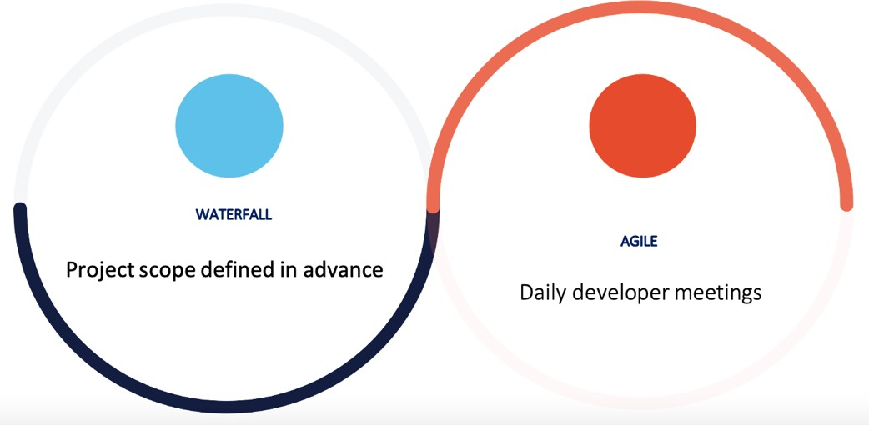

**4.2. Project Phases**

**Phase 1: Planning and Assessment (Month 1-2)**

1. **Project Kickoff:**
   * Conduct a kickoff meeting with all stakeholders to align on project goals, objectives, and timelines.
   * Identify key stakeholders and their roles.
2. **Requirement Gathering:**
   * Collaborate with Business Analysts and Automation Developers to gather detailed business automation and technical requirements.
   * Conduct workshops and interviews to understand current processes and identify automation opportunities.
3. **Technical Assessment:**
   * Assess the current technical architecture and infrastructure.
   * Identify gaps and areas for optimization to align with organizational goals.

**Phase 2: Design and Documentation (Month 3)**

1. **Solution Design:**
   * Design automation solutions using UiPath and related technologies.
   * Create detailed Solution Design Documents (SDDs) outlining the architecture, workflows, and integration points.
2. **Infrastructure Setup:**
   * Set up the RPA infrastructure, including UiPath Orchestrator, licenses, servers, and databases.
   * Ensure optimal configuration and utilization of resources.
3. **Documentation:**
   * Document all processes, configurations, and setups.
   * Create transparent records of all licenses, servers, access credentials, ports, IP addresses, and related information.

**Phase 3: Development and Testing & UAT(Month 4-8)**

1. **Development:**
   * Develop automation workflows based on the SDDs.
   * Ensure adherence to best practices and coding standards.
2. **Testing:**
   * Conduct unit testing, integration testing, and user acceptance testing (UAT) to ensure the automation solutions meet the requirements.
   * Perform critical code reviews and provide root cause analysis (RCA) for any exceptions.
3. **Exception Handling:**
   * Implement effective exception handling mechanisms.
   * Conduct RCA for issues and provide justifications and resolutions.

**Phase 4: Deployment and Monitoring (Month 9-10)**

1. **Deployment:**
   * Deploy automation solutions to the production environment.
   * Ensure seamless integration with existing systems and processes.
2. **Monitoring:**
   * Monitor the performance of automation processes using UiPath Orchestrator and UiPath Insights.
   * Track key performance indicators (KPIs) and metrics to measure success.
3. **Optimization:**
   * Continuously monitor and enhance automation processes.
   * Address any issues or bottlenecks identified during the monitoring phase.

**Phase 5: Knowledge Transfer and Maintenance (Month 11-12)**

1. **Knowledge Transfer:**
   * Facilitate knowledge transfer sessions with the project team.
   * Provide training and support to ensure smooth operation and maintenance of automation solutions.
2. **Maintenance:**
   * Conduct regular maintenance and updates to the RPA infrastructure and automation solutions.
   * Ensure compliance with best practices and organizational standards.
3. **Project Closure:**
   * Conduct a project closure meeting to review the outcomes and gather feedback.
   * Document lessons learned and best practices for future projects.

This roadmap provides a structured approach to implementing the RPA Technical Architecture Program, ensuring alignment with organizational goals and successful outcomes.

**5. Team Structure**

| **Role** | **Responsibilities** |
| --- | --- |
| **RPA Architect** | Lead the design and architecture of the automation platform |
| **RPA Developer** | Develop automation workflows using UiPath Studio |
| **Business Analyst** | Gather business requirements and align them with technical specifications |
| **Infrastructure Lead** | Set up and manage UiPath Orchestrator, licenses, and servers |
| **QA Engineer** | Conduct testing to ensure the solution meets business and technical requirements |
| **Project Manager** | Oversee project timelines, deliverables, and stakeholder communication |

**6. Key Milestones & Timeline**

| **Milestone** | **Timeline** |
| --- | --- |
| Project Kickoff,Technical Assessment, Feasibility Testing & Requirement Gathering | Month 1-2 |
| Architecture Design Completion | Month 3 |
| Development & Initial Testing | Months 4–7 |
| UAT & Deployment Preparation | Month 8–9 |
| Go-Live & Hypercare | Month 10 |
| Ongoing Support & Process Optimization | Months 11–12 |

**8. Risk Management**

| **Risk** | **Mitigation Strategy** |
| --- | --- |
| Delays in requirements finalization | Conduct early-stage workshops with stakeholders |
| Infrastructure issues during deployment | Set up a dedicated support team for infrastructure |
| Integration challenges with legacy systems | Perform thorough testing in pre-production environments |

**9. Deliverables**

* **Process Design Document (PDD)**
* **Solution Design Document (SDDs)**
* **Root Cause Analysis (RCA) Reports**
* **Process Code Review Template**
* **Technical Testing Plan**
* **Exception Handling Procedures**
* **Infrastructure Configuration Records**

**9. Conclusion**

Netlink is committed to helping Dubai Holdings successfully implement their RPA Technical Architecture Program. By leveraging our deep expertise in UiPath and automation best practices, we will ensure that the RPA platform is scalable, efficient, and aligned with your long-term strategic objectives.

We look forward to collaborating with you to drive your automation initiatives and deliver measurable business value.